**SS Fitness: Your Personal Fitness Companion**

**(React Application)**

**Team Leader: Suganthiya.S**

**Team Members: Sowmiya.M, Sowmiya. V, Sindhuja.B**

**Introduction:**

Welcome to **SS Fitness: Your Personal Fitness!** Our mission is to help you achieve your fitness goals by providing a customized workout plan, nutritional guidance, and motivational tools in one easy-to-use app. Whether you're looking to build strength, lose weight, or improve overall health, SS Fitness offers the tools and support you need to succeed.

**Description:**

**Personalized Fitness Plans:** SS Fitness customizes your fitness experience by offering personalized workout plans based on your goals, experience level, and available equipment. Whether you're looking to lose weight, build muscle, improve cardiovascular health, or enhance flexibility, SS Fitness tailors each program to suit your individual needs.

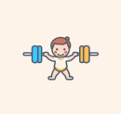**Progress Tracking:** Stay motivated by tracking your progress over time. SS Fitness helps you visualize your achievements with detailed reports on workouts completed, calories burned, body measurements, and more.

**Nutrition Support:** SS Fitness understands that fitness isn’t just about working out; it’s about fueling your body properly. That’s why the app includes a comprehensive nutrition tracker to help you log meals, track calories, and stay on top of your macro and micronutrient intake.

**Motivational Tools & Community:** Staying motivated is key to success. SS Fitness offers a range of features designed to keep you inspired, including daily tips, motivational quotes, and reminders.

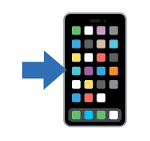**Integration with Wearable Devices:** For a more seamless experience, SS Fitness integrates with popular fitness trackers like Apple Watch, Fitbit, and Google Fit, allowing you to sync your workouts, steps, and heart rate data automatically

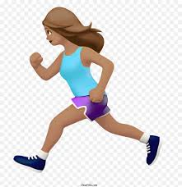**Flexibility & Convenience:** SS Fitness understands that life can be busy, which is why it allows you to work out whenever and wherever works best for you. Whether you have 10 minutes or an hour to spare, SS Fitness provides quick, efficient workouts .

**In-App Guidance and Support:** Need help with a specific exercise or workout routine? SS Fitness offers detailed video demonstrations and instructions for every exercise, ensuring that you perform each movement with the correct form.

**Join the SS Fitness Journey:** With SS Fitness, you’re not just downloading another fitness app—you’re joining a community committed to personal growth, health, and fitness.

Download **SS Fitness** today and start your journey toward a healthier, stronger you. Let us help you unlock your potential, achieve your goals, and make fitness an exciting part of your everyday life.

### **Project Goals & Objectives for SS Fitness-Your Personal Fitness:**

1. **Deliver Personalized Fitness Plans:**

* Provide customized workout plans based on users’ fitness goals, levels, and available equipment.
  + Tailor workout intensity and structure to ensure each user’s unique needs are met for effective results.

1. **Make Fitness Accessible and Easy to Use:**
   * Ensure the app is simple, intuitive, and suitable for users of all fitness levels, with clear navigation and easy-to-follow workouts.
   * Provide educational resources and support to help users stay informed and improve their fitness knowledge.
2. **Personalized Fitness Plans:**

* **Objective:** Create customizable workout routines based on user preferences, fitness levels, goals, and available equipment.

1. **Nutrition Guidance & Tracking:**

* **Objective:** Provide personalized meal plans that align with users’ goals (e.g., fat loss, muscle gain) and dietary preferences (e.g., keto, vegan).

1. **Community Engagement & Interaction:**

* **Objective:** Integrate social features like community feeds, challenges, and in-app messaging to foster interaction among users.

1. **User-Friendly Interface:**

* **Objective:** Develop an easy-to-navigate app interface that is intuitive and accessible to users of all technical levels.

### **Core Features of SS Fitness-Your Personal Fitness:**

1. **Personalized Workout Plans:**

* **Custom Routines:** SS Fitness offers personalized workout plans based on the user’s fitness level, goals (e.g., weight loss, muscle gain, improved endurance), and available equipment (e.g., home or gym-based).
* **Adaptive Programs:** As users progress, the app adjusts workout intensity to keep challenging them and to prevent plateaus.

1. **Motivational Features:**

* **Daily Tips & Reminders:** Daily motivational quotes and fitness tips to keep users inspired.
* **Achievements & Badges:** Gamified achievements to reward users for completing milestones and hitting goals.

1. **Community & Social Features:**

* **In-App Challenges:** Users can join daily, weekly, or monthly fitness challenges to stay motivated and compete with others.
* **Leader boards:** Track progress and compare achievements with friends or community members.

1. **Customizable Workouts:**

* **Quick Workouts:** Time-efficient routines for users with busy schedules, offering workouts that range from 5 to 30 minutes.
* **Home & Gym Options:** A variety of workouts that can be done at home with minimal equipment or at the gym with full equipment.

1. **Flexible Scheduling & Reminders:**

* **Workout Reminders:** Schedule workouts and receive reminders to stay consistent with your fitness routine.
* **Flexible Plans:** SS Fitness adapts to changes in the user’s schedule, allowing them to modify or skip workouts without losing progress.

1. **User-Friendly Interface:**

* **Simple Navigation:** Easy-to-use and intuitive design, with clear sections for workouts, progress tracking, nutrition, community, and more.
* **Customizable Dashboards:** Users can personalize their home dashboard to highlight their most-used features for quick access.

**Technical Architecture:**

Rapid API (Backend)

API Client

UI of the Application

SS Fitness prioritizes a user-centric approach from the ground up. The engaging user interface (UI), likely built with a framework like React Native, keeps interaction smooth and intuitive. An API client specifically designed for SS Fitness communicates with the backend, but with a twist: it leverages Rapid API.

**PRE-REQUISITES:**

Here are the key prerequisites for developing a frontend application using React.js:

**✔ Node.js and npm:**

Node.js is a powerful JavaScript runtime environment that allows you to run JavaScript code on the local environment. It provides a scalable and efficient platform for building network applications.

Install Node.js and npm on your development machine, as they are required to run JavaScript on the server-side.

● Download: <https://nodejs.org/en/download/>

* Installation instructions: <https://nodejs.org/en/download/package-manager/>

**✔ React.js:**

React.js is a popular JavaScript library for building user interfaces. It enables developers to create interactive and reusable UI components, making it easier to build dynamic and responsive web applications. Install React.js, a JavaScript library for building user interfaces.

● Create a new React app:

npx create-react-app my-react-app Replace my-react-app with your preferred project name.

● Navigate to the project directory:

cd my-react-app

● running the React App: With the React app created, you can now start the development server and see your React application in action.

● Start the development server**: npm start**

This command launches the development server, and you can access your React app at http://localhost:3000 in your web browser.

**✔ HTML, CSS, and JavaScript:** Basic knowledge of HTML for creating the structure of your app, CSS for styling, and JavaScript for client-side interactivity is essential.

**✔Version Control:** Use Git for version control, enabling collaboration and tracking changes throughout the development process. Platforms like GitHub or Bitbucket can host your repository.

• Git: Download and installation instructions can be found at: <https://git-scm.com/downloads>

**✔ Development Environment:** Choose a code editor or Integrated Development Environment (IDE) that suits your preferences, such as Visual Studio Code, Sublime Text, or WebStorm.

• Visual Studio Code: Download from <https://code.visualstudio.com/download>

• Sublime Text: Download from <https://www.sublimetext.com/download>

• WebStorm: Download from https://www.jetbrains.com/webstorm/download

To get the Application project from drive: Follow below steps:

**✔ Get the code:**

• Download the code from the drive link given below:

<https://drive.google.com/file/d/1tM834UZF8P6XOeQJWaRtzPF0H5SvySb9/view?usp=drive_link>

Install Dependencies:

• Navigate into the cloned repository directory and install libraries: cd fitness-app-react npm install

**✔ Start the Development Server:**

• To start the development server, execute the following command:

npm start

**Access the App:**

• Open your web browser and navigate to <http://localhost:3000>.

• You should see the application's homepage, indicating that the installation and setup were successful.

You have successfully installed and set up the application on your local machine. You can now proceed with further customization, development, and testing as needed.

**Project structure:**

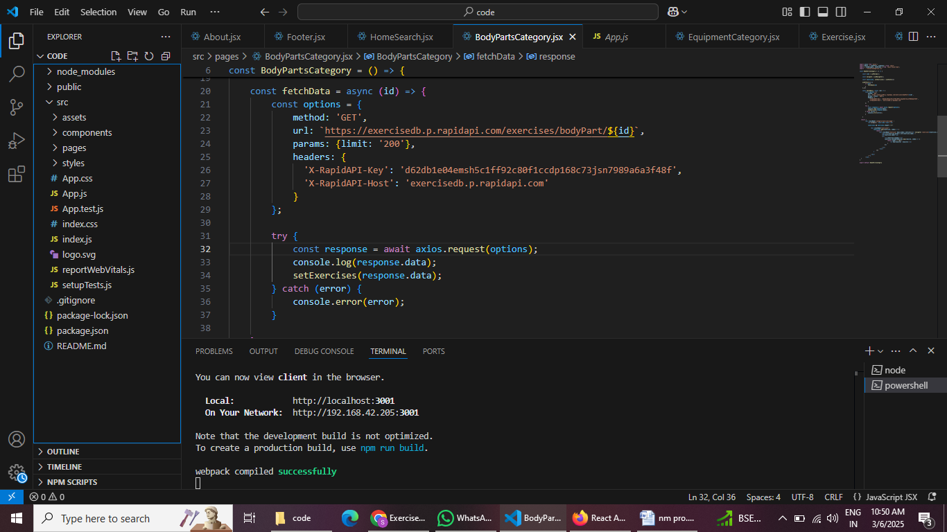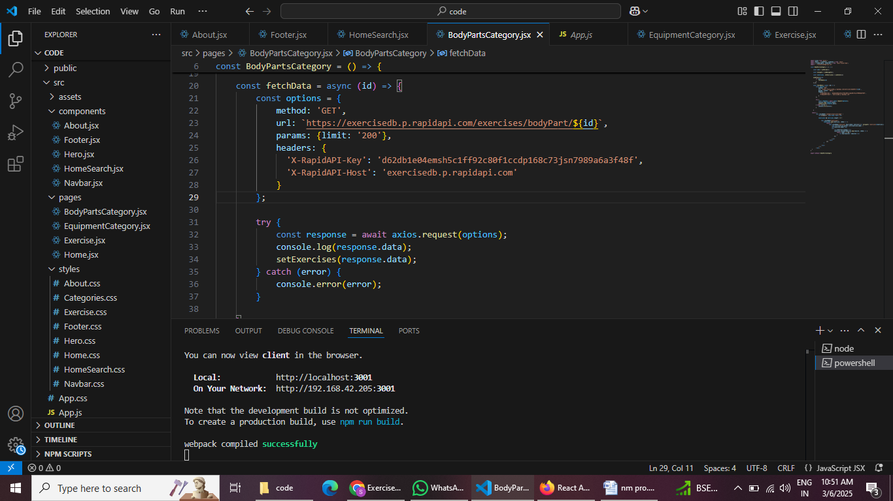

In this project, we’ve split the files into 3 major folders, Components, Pages and Styles. In the pages folder, we store the file that acts as pages at different URLs in the application. The components folder stores all the files that return the small components in the application.

**Project Flow:**

**Project demo:**

Before starting to work on this project, let’s see the demo.

**Demo link:**

<https://drive.google.com/file/d/1Xr_2tM-AzTdET4rW-XsUp0Xfx5MuJEVk/view?usp=drive_link>

**Use the code in:**

<https://drive.google.com/file/d/1tM834UZF8P6XOeQJWaRtzPF0H5SvySb9/view?usp=drive_link>

**Milestone 1: Project setup and configuration.**

**● Installation of required tools:**

To build the SS Fitness app, we'll need a developer's toolkit. We'll leverage React.js for the interactive interface, React Router Dom for seamless navigation, and Axios to fetch fitness data. To style the app, we'll choose either Bootstrap or Tailwind CSS for pre-built components and a sleek look. Open the project folder to install necessary tools. In this project, we use:

* React Js
* React Router Dom
* React Icons
* Bootstrap/tailwind css
* Axios

● for further reference, use the following resources

* <https://react.dev/learn/installation>
* <https://react-bootstrap-v4.netlify.app/getting-started/introduction/>
* <https://axios-http.com/docs/intro> <https://reactrouter.com/en/main/start/tutorial>

**Milestone 2: Project Development**

❖ Setup the Routing paths

Setup the clear routing paths to access various files in the application.

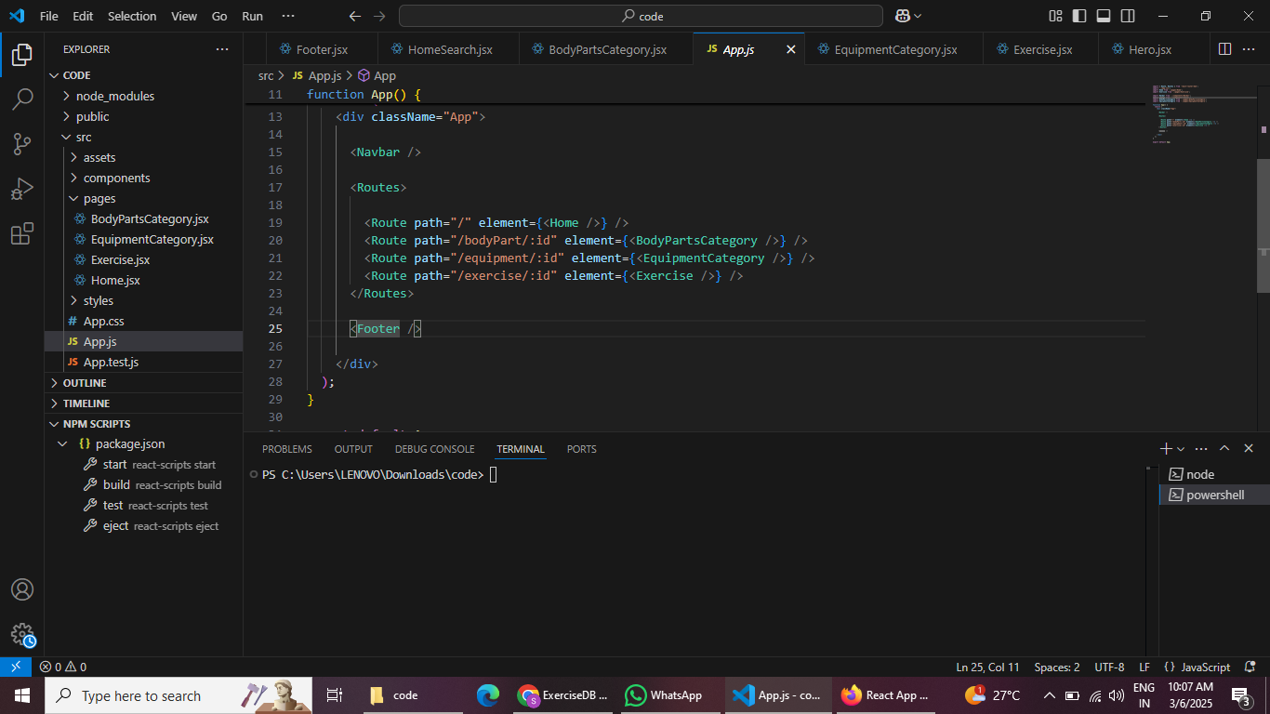

❖Develop the Navbar and Hero components

❖ Code the popular search/categories components and fetch the categories from rapid Api.

❖Additionally, we can add the component to subscribe for the newsletter and the footer.

❖ Now, develop the category page to display various exercises under the category.

❖ finally, code the exercise page, where the instructions, other details along with related videos from the YouTube will be displayed.

* **Fetching exercises under particular category**

To fetch the exercises under a particular category, we use the below

Code.

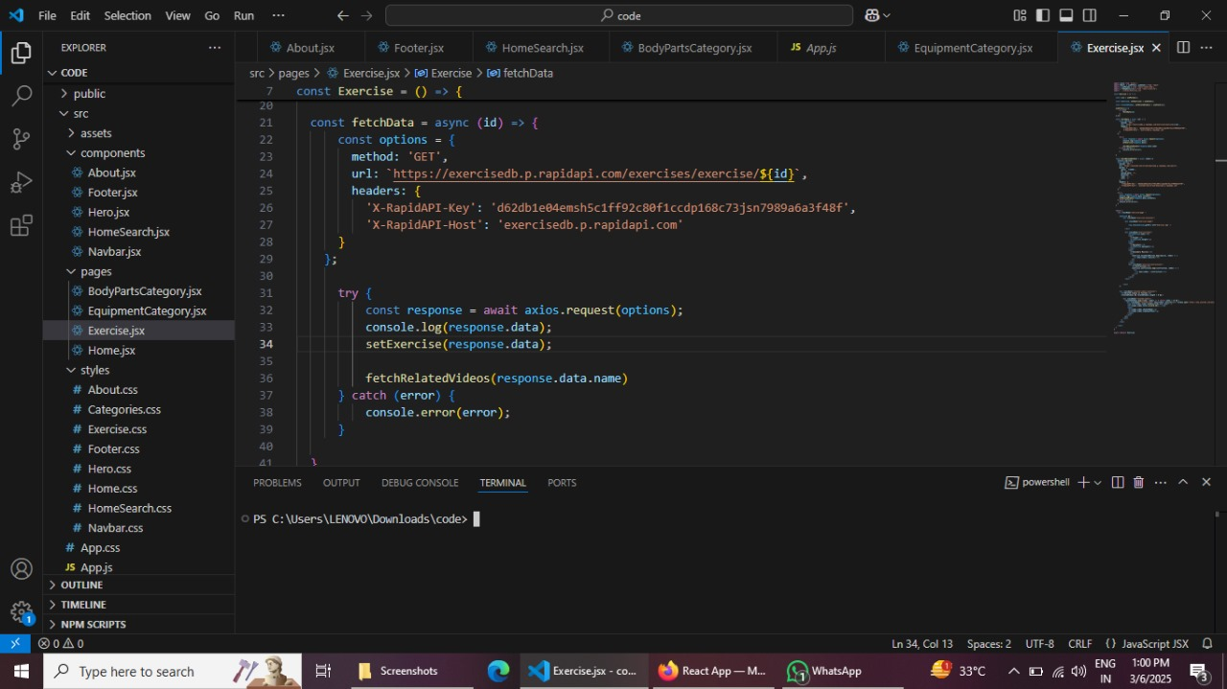

.

* **Fetching Exercise details**

Now, with the help of the Exercise ID, we fetch the details of a particular exercise with API request.

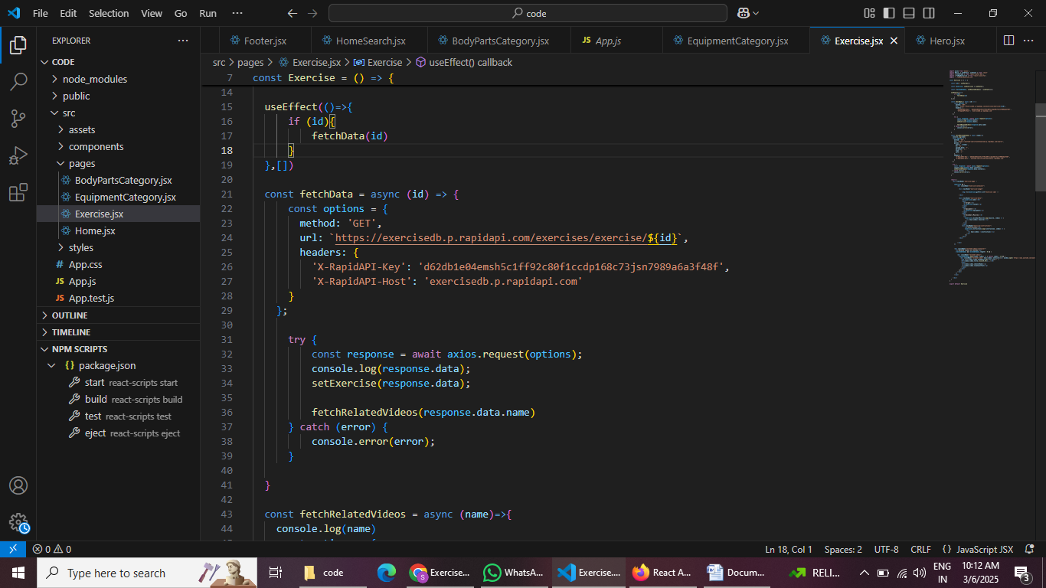

**Fetching related videos from YouTube:**

Now, with the API, we also fetch the videos related to a particular exercise with code given below.

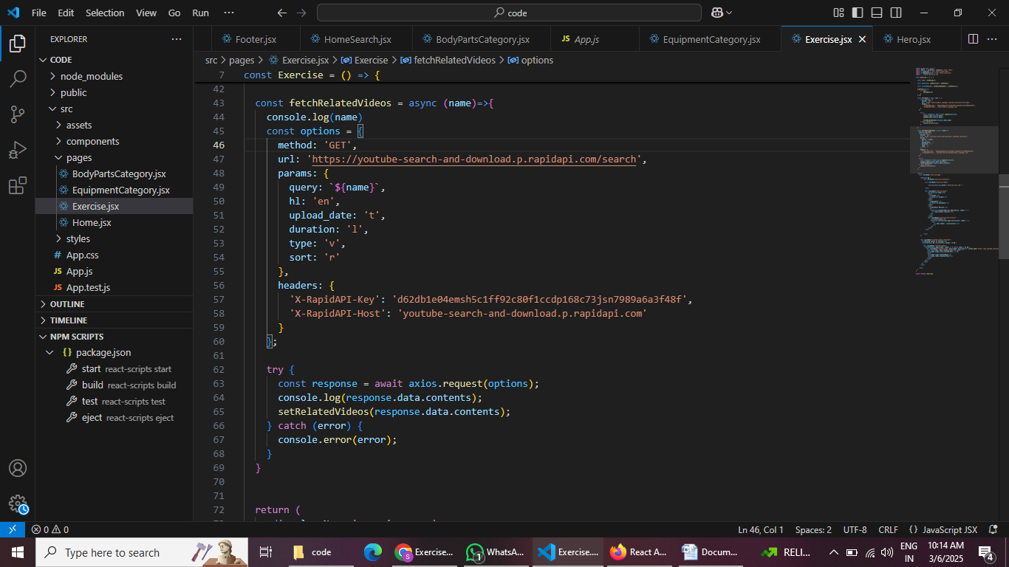

**Project Execution:**

After completing the code, run the react application by using the command “npm start” or “npm run dev” if you are using vite.js

Here are some of the screenshots of the application.

* **Hero component:**

This section would showcase trending workouts or fitness challenges to grab users' attention.

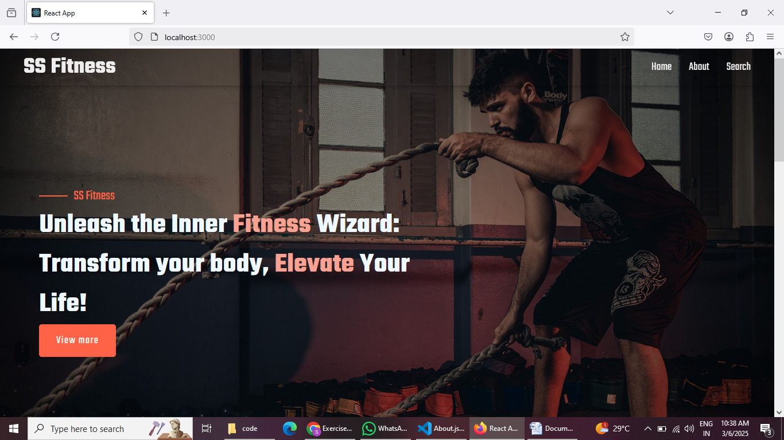

* **About:**

SS Fitness isn't just another fitness app. We're meticulously designed to transform your workout experience, no matter your fitness background or goals.

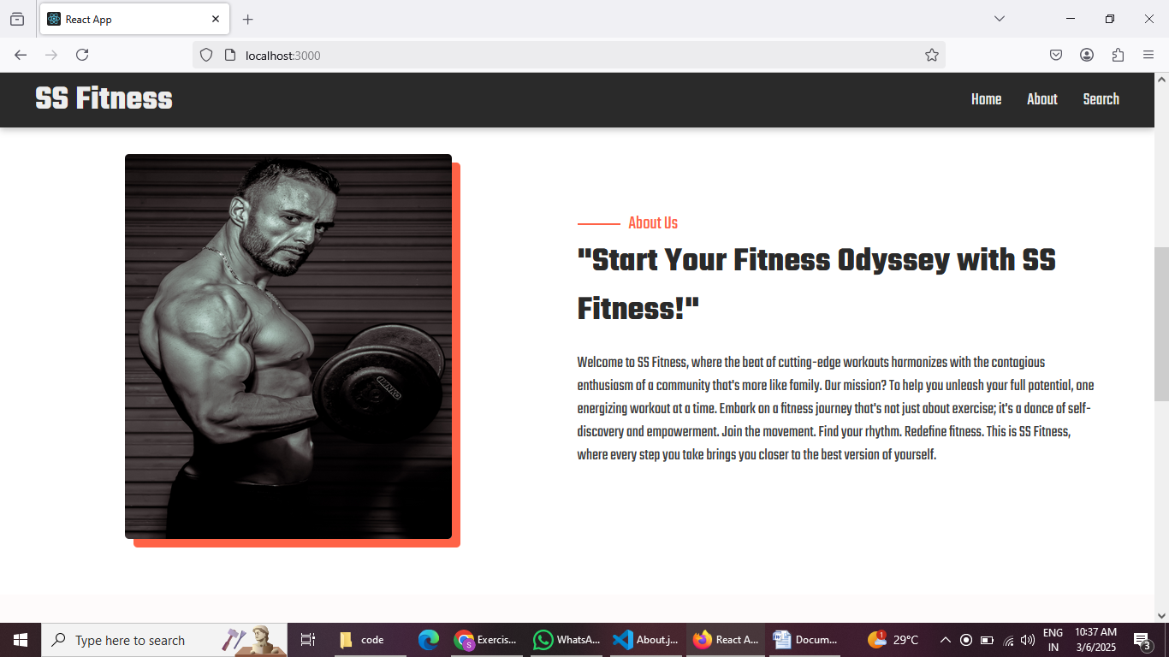

* **Search:**

SS Fitness makes finding your perfect workout effortless. Our prominent search bar empowers you to explore exercises by keyword, targeted muscle group, fitness level, equipment needs, or any other relevant criteria you have in mind. Simply type in your search term and let SS Fitness guide you to the ideal workout for yourgoals.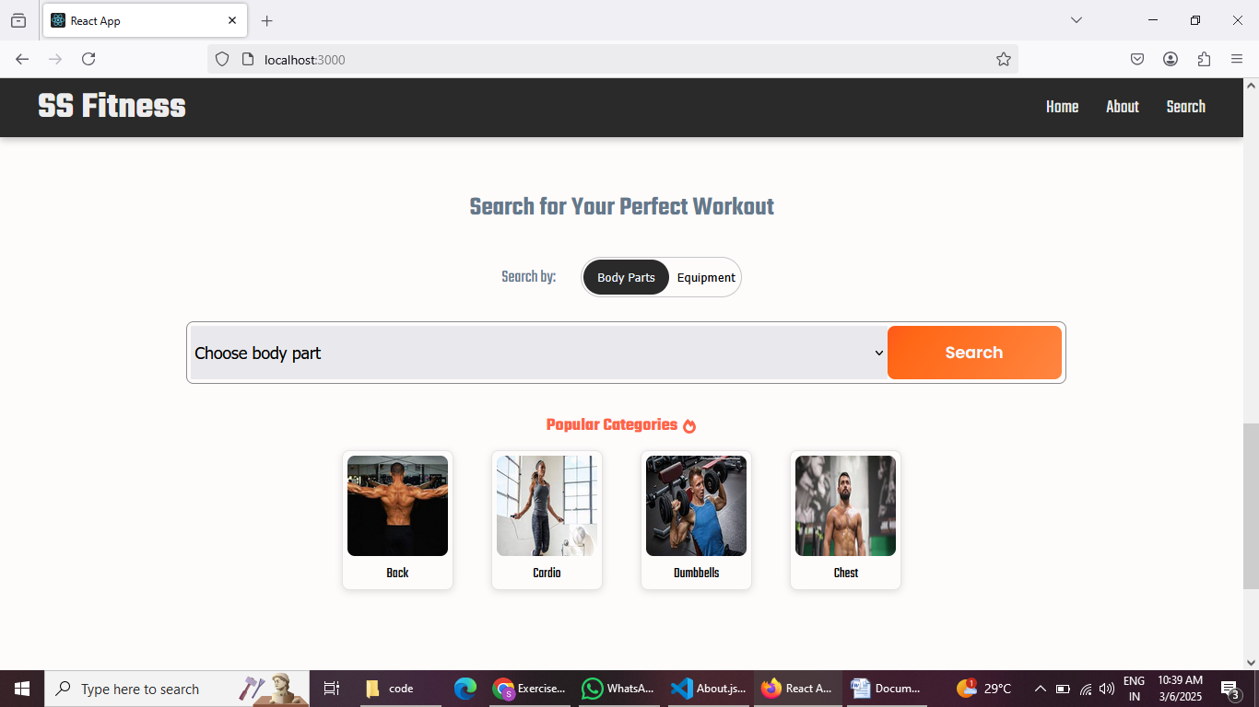

* **Category page:**

SS Fitness would offer a dedicated section for browsing various workout categories. This could be a grid layout with tiles showcasing different exercise types (e.g., cardio, strength training, and yoga) with icons or short descriptions for easy identification.

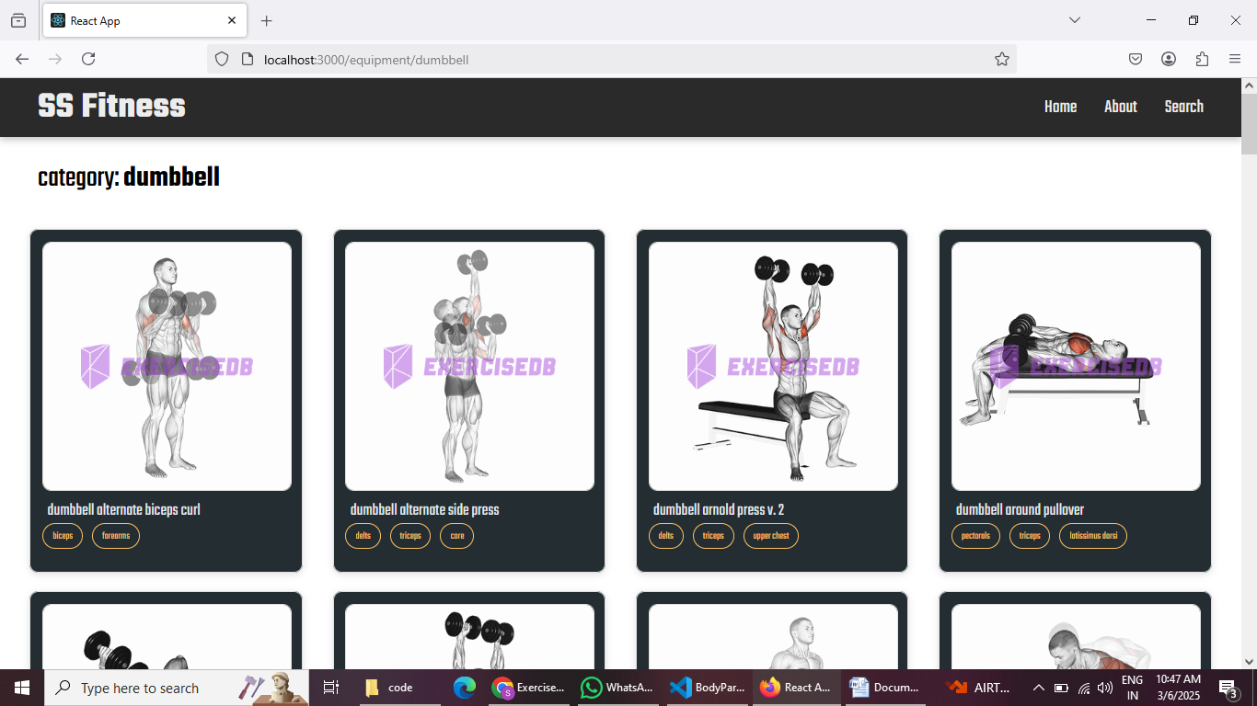

* **Exercise page :**

This is where the magic happens! Each exercise page on SS Fitness provides a comprehensive overview of the chosen workout. Expect clear and concise instructions, accompanied by high-quality visuals like photos or videos demonstrating proper form. Additional details like targeted muscle groups, difficulty level, and equipment requirements (if any) will ensure you have all the information needed for a safe and effective workout.

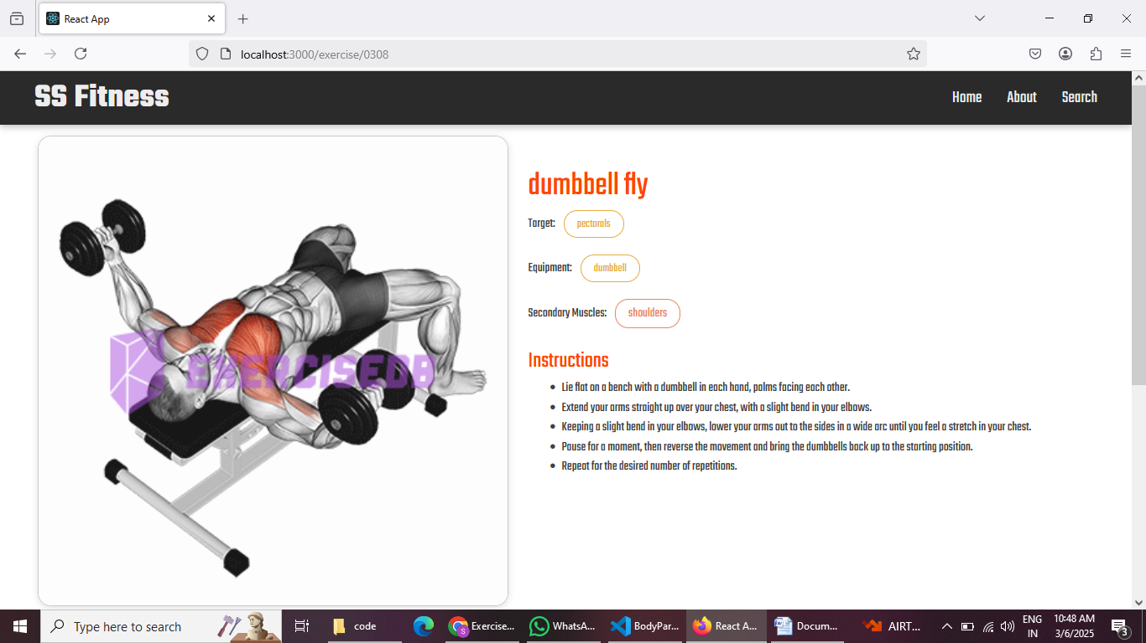

**Demo Link:**

<https://drive.google.com/file/d/1Xr_2tM-AzTdET4rW-XsUp0Xfx5MuJEVk/view?usp=drive_link>

**Happy Coding……..**